Wolf aspects

Scientific:

<https://www.motherjones.com/environment/2011/04/10-reasons-protect-wolves-climate-change/>

The lawmakers argue that the bill alleviates stress on big-game herds and helps out ranchers and farmers, whose livestock fall victim to the predators. The bill would lift protections for wolves in five Western states and allow wolf hunting [to resume in Montana and Idaho](http://www.latimes.com/news/nationworld/nation/la-na-wolf-settlement-20110319,0,6904441.story). Environmentalists worry that removing wolves from the ESA list could open the doors to allow other endangered species to be delisted as well.

100 carrying capacity of yellowstone

Thus, a breeding pair produces one litter of pups each spring, but in areas of high prey abundance more than one female in a pack may give birth. An average litter size for gray and red wolves is 4 to 6, but sometimes fewer pups are born and sometimes more.

<https://defenders.org/wildlife/gray-wolf>

1,675 in the Northern Rockies and 275 in the Pacific Northwest.

Breeding season occurs once a year late January through March

<https://www.nps.gov/yell/learn/ys-24-1-wolf-restoration-in-yellowstone-reintroduction-to-recovery.htm>

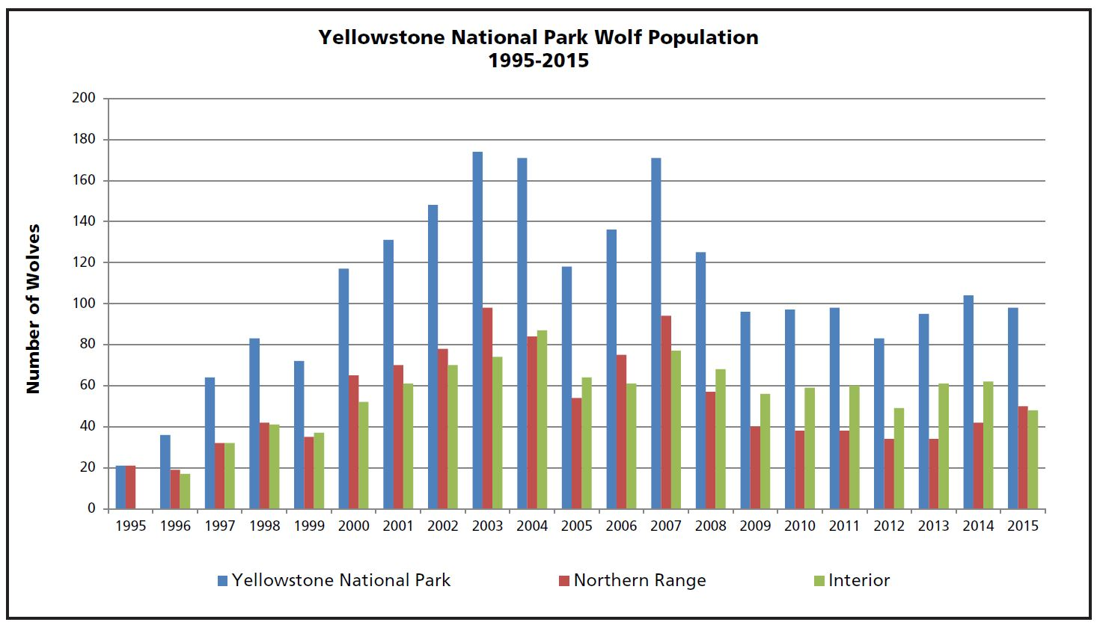

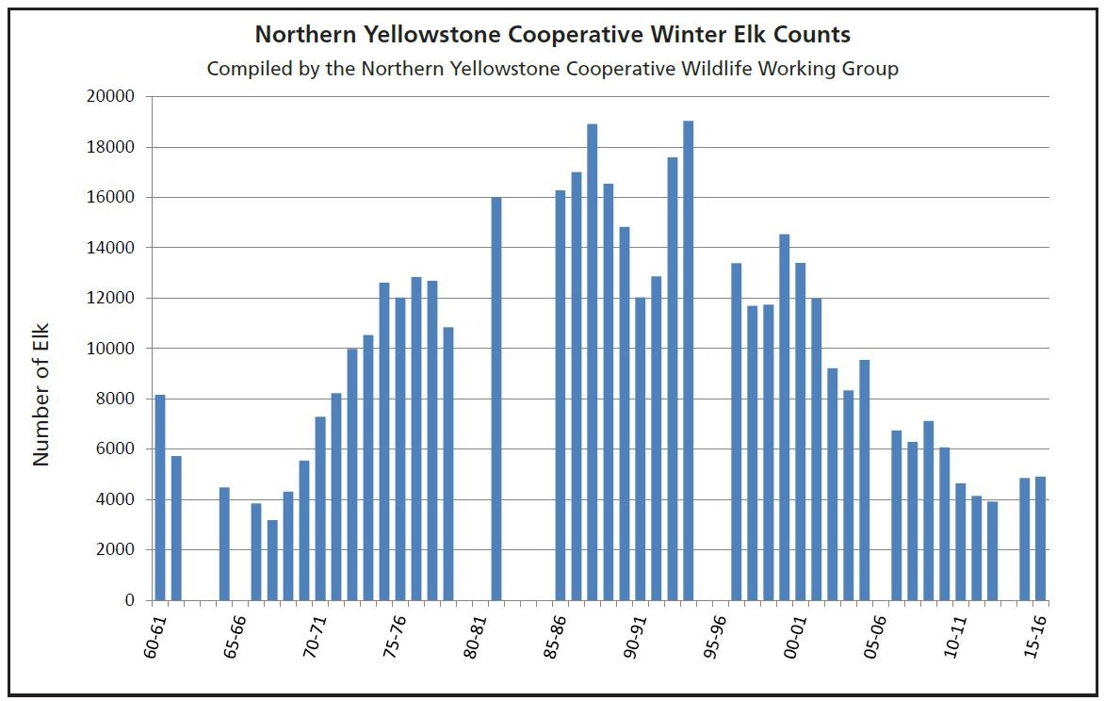

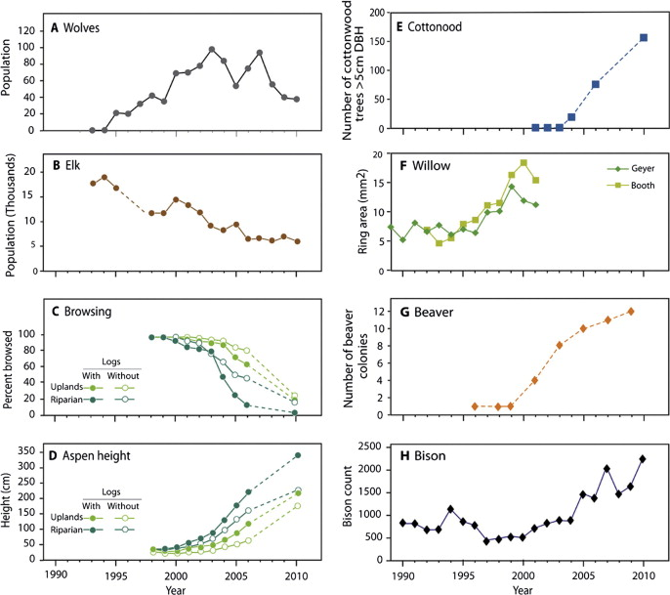

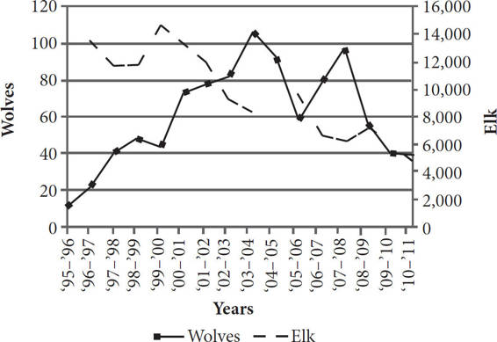

<https://www.nytimes.com/2017/05/01/science/wolves-hunting-yellowstone-national-park.html>

That’s because the park’s wolf population has hovered for the last decade at 100, give or take, which experts consider Yellowstone’s carrying capacity.

Economic:

social/political: